**Test for Technology Consultants**

# Structure of coach

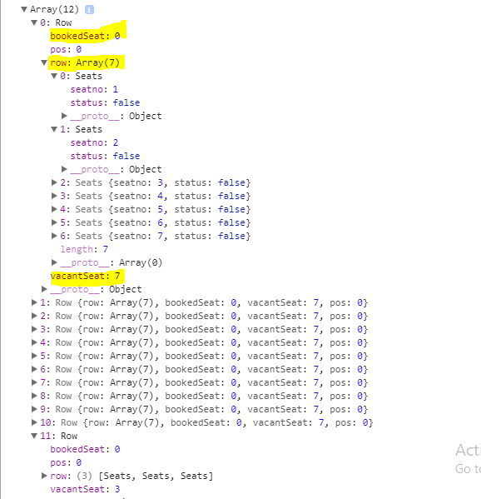

# Note And Assumptions

* Defined an array of size 12 to store the no of rows. Every row contains 7 seats with seat no, seat status, booked no of seats and vacant seats.
* If user inputs 7 seats then the system will traverse the array from beginning to find the available input seats (priority will be given so that all the input seats are booked in a single row).
* If user inputs any value less than 7 and that value is equal to or less than the vacant seat of a partially filled row, then the system will book the required seats in that particular row.

# Input Validations

* User must input some integer value within the range of 1-7.
* If required seats are more than the total number of available seats then an error message will be shown to the user.

# Uncompleted task as part of the assignment

If seats are not available in one row then the booking should be done in such a way that the nearby seats are booked.